**Migration Process:**

**[STEP 1: Scan bots to check the compatibility to migrate]**

* Download Automation Anywhere Bot Scanner form the below link:

<https://automationanywhere.app.box.com/s/f7cf0g4g7yf0ltwmo18eqci8j3qd53m4/file/775628743012>

* Launch the Automation Anywhere Bot Scanner to select the task bots folder location and destination location to save the scan results and click on create report.

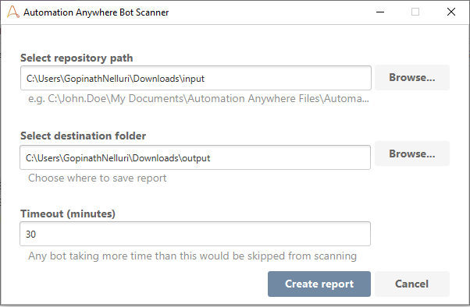

* Bot scanner will start scanning all the bots from the repository path and generates the report.

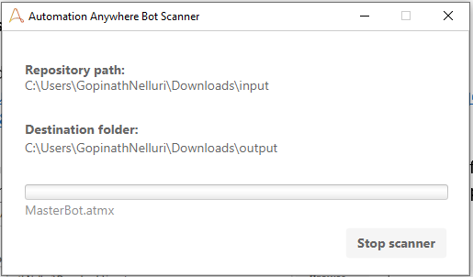 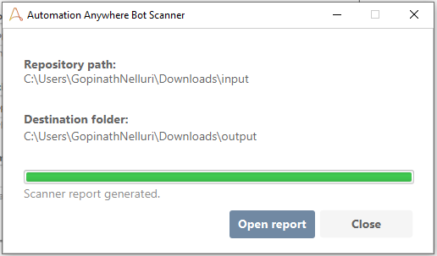

* The generated report will show the bot compatibility to migrate from v10/v11 to v2019 along with details of the bots that are not compatible for migration and the commands which cause the migration incompatibility issues.

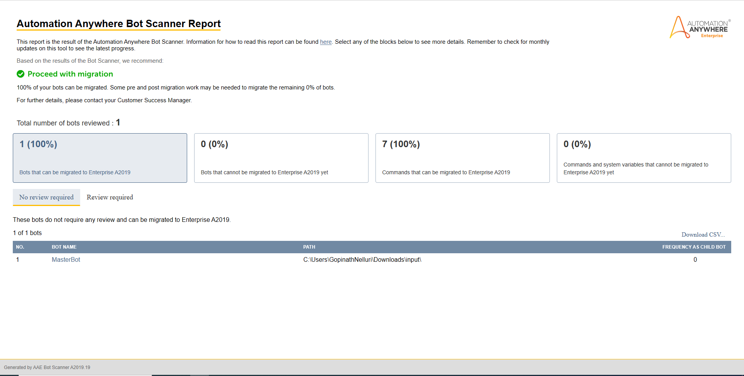

**[STEP 2: Migrate the compatible bots from AAv10/AAv11 to AAv2019]**

* A newly created task bot will look like this:

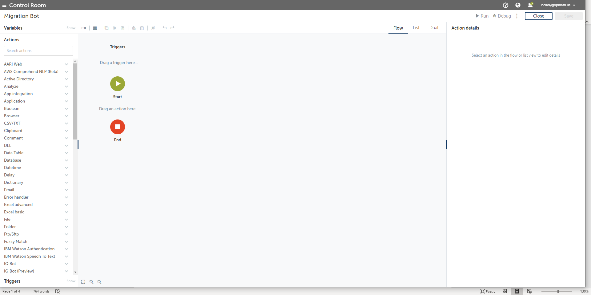

* Add a migration action command to the BOT

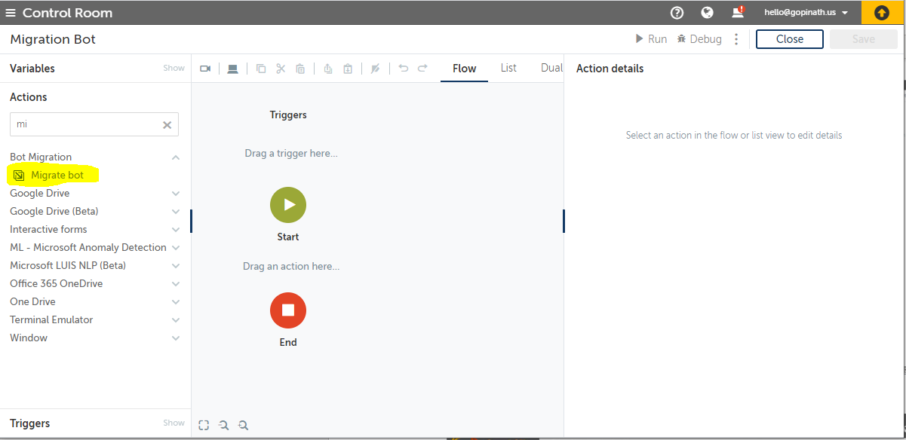

* Choose the bot file form the control room or from desktop to proceed with migration of the respective bot task.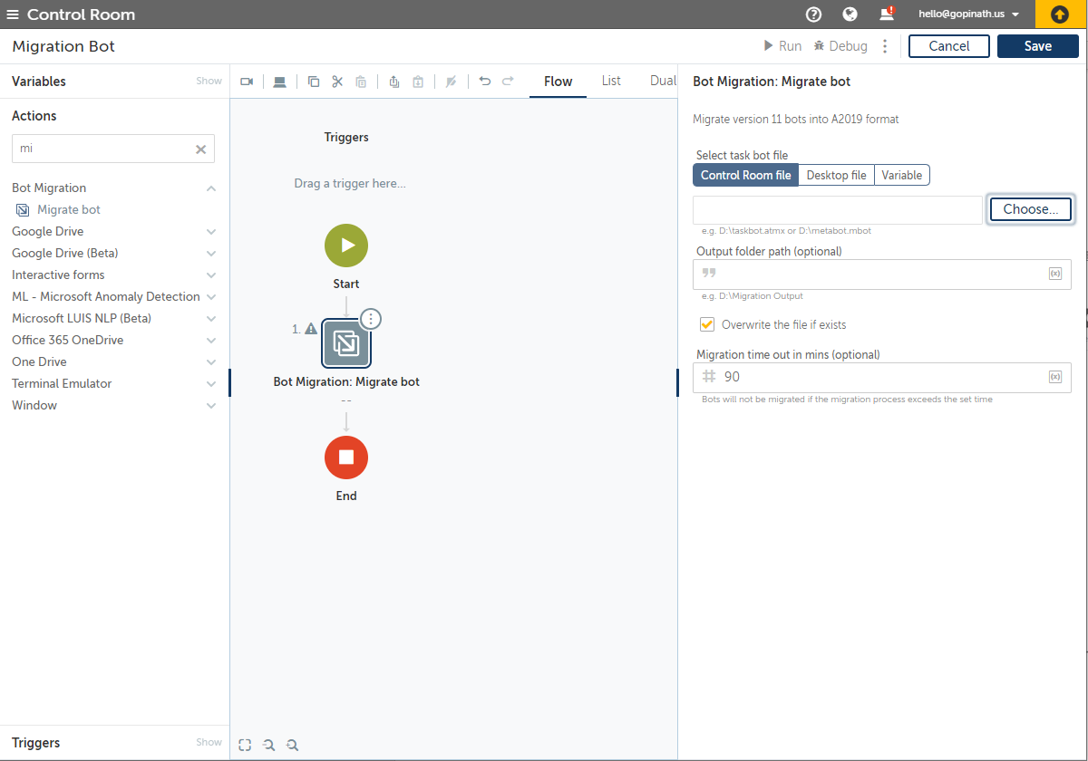

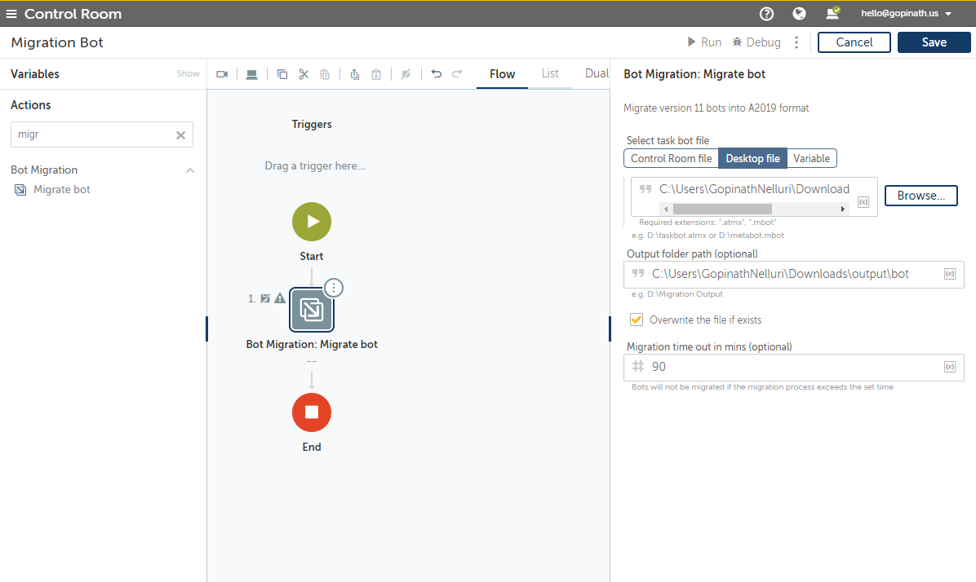

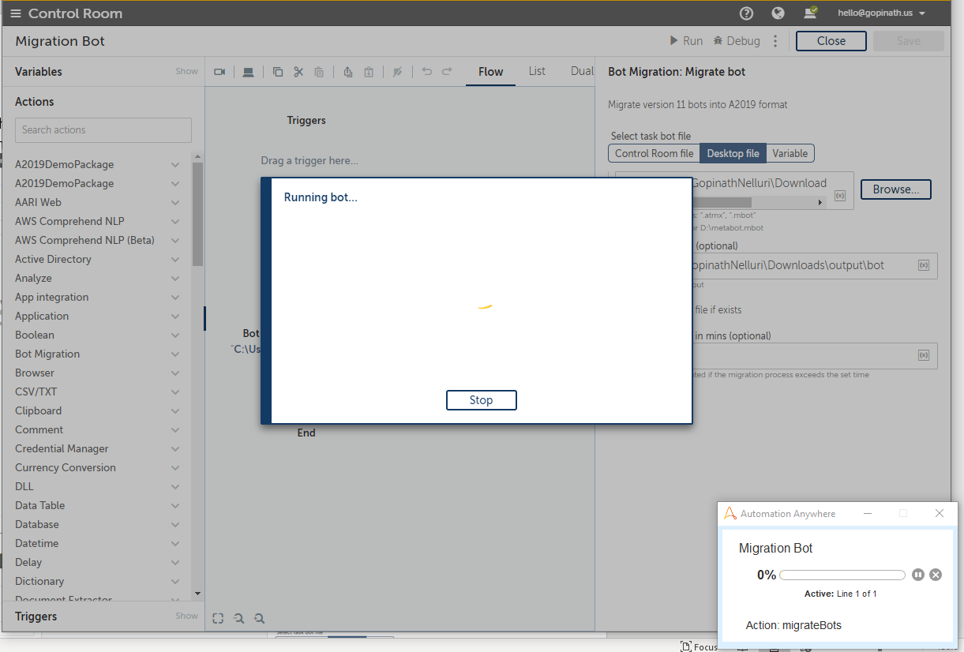

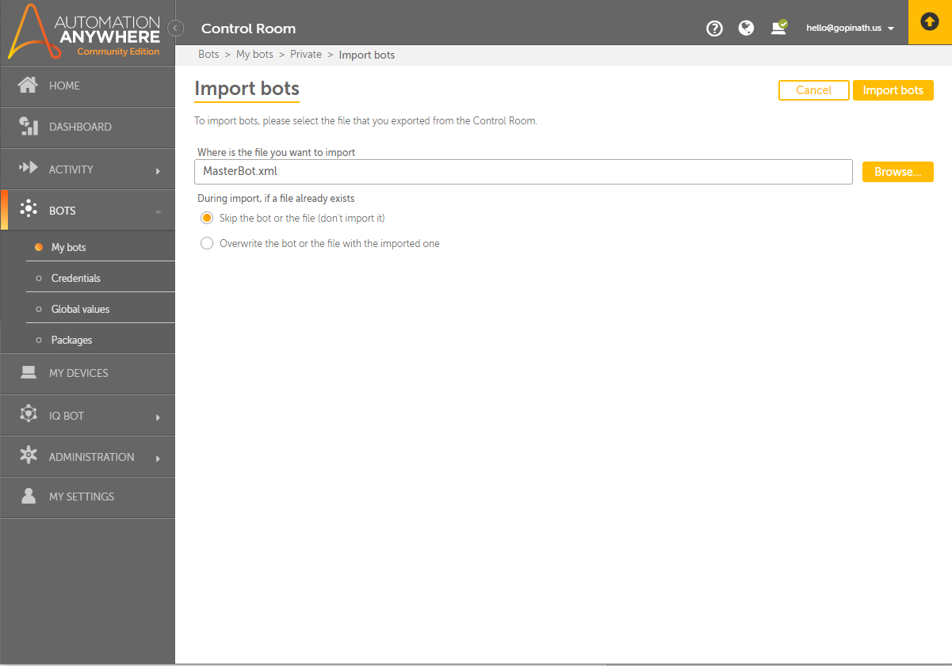

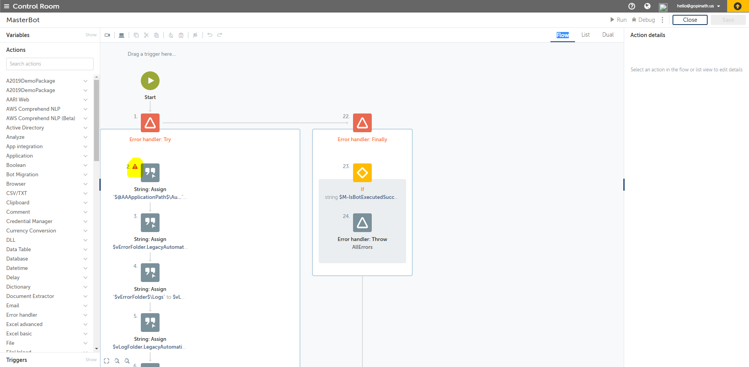

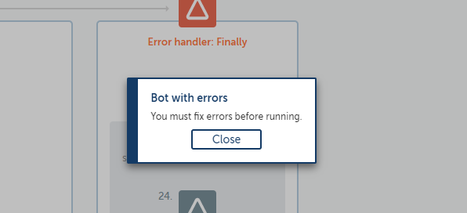

|  |  |  |  |
| --- | --- | --- | --- |
| **Version** | **11.x** | **A2019** | Action to be taken  when Migrated |
|  |  |  |  |
| 1. | Single $ can be used by the user to inject variables | Single $ is reserved for Automation Anywhere Enterprise use, so all user entries of a single dollar sign are automatically replaced with two dollar signs ($$). |  |
| 2. | The DLLs in the MetaBots use the Execute command to run a function from that DLL. | After migration to A2019, each Execute command is converted to Open, Run function, and Close actions of the DLL package. | Information about which function to  run from the DLL, which parameters  to use, and other details in the  Execute command is migrated to  the Run action. |
| 3. | For 11.x command using a windows title field configured with a user defined variable, the migration process migrates the bot by adding the Set Title action just above the respective command. | A2019 does not allow user variables in the Windows Title field. | Use the Set Title action to achieve  the same behavior. |
| 4. | In 11.x, when a bot contains more than one command with the resize window option selected, the window is resized to the dimensions specified by the first command. | In A2019, the window is resized each time the bot encounters an action with the resize window option selected to ensure that window dimensions match the dimensions at which they were configured. |  |
| 5. | In 10.x/11.x, loop indexing of table starts with 1 and increments by 1. | A2019 starts indexing with 0 and increments by 1. |  |
| 6. | In11.x, few actions store the return values to the $Clipboard$ system variable. | This is not supported in A2019 and when the bot with these functionality is migrated, the migration process assigns the values to a temporary variable and then assigns the value to the A2019 $System:Clipboard$ system variable by adding the Copy To action to the Clipboard package. |  |
| 9. | In 11.x, users can store the return values yielded from certain commands in different types of variables | In A2019, these values are stored in a specific type of variable only. For example, if a command returns a value to an array for a specific cell, then in A2019, we store the value in a temporary string variable. Then in the next action, we store this temporary value to an actual array variable to ensure that the bot execution logic stays intact. |  |
| 10. | V11.x have Delay, Delay in Milliseconds and Delay in Seconds commands. | In 2019, These commands are migrated to Delay action and options of ‘Delay in Milliseconds’ and ‘Delay in Seconds’ have changed as radio options within the Time unit area. |  |
| 11. | 11.x uses ODBC drivers for Database Connections. | A2019 uses JDBC drivers. The SQL Query action is called Read from in A2019. |  |
| 12. | Run Stored Procedure is the command used and there are no mandatory fields. | The Parameter name and Output Parameter are mandatory fields for Run Stored Procedure. | When we migrate the bot parameter  name and output parameter type should  be given. |
| 13. | There is no concept of Session for email commands. | Connect and Disconnect actions make sure that Email session is started and closed. |  |
| 14. | There is Get All Messages command with a save attachment Option. | Get All Messages command is migrated to the loop action with the iteration set to For all Each mail in Mailbox. |  |
|  |  |  |  |

* For each variable passed as input in 11.x or 10.x bot, a line is added in the migrated bot in Enterprise A2019. For example, if you are passing 100 variable as input in 11.x bot, after migration that bot has 100 new lines.
* 11.x or 10.x allows you to specify a session name to open a file or establish a connection and use a variable in a loop command to use the same session. After migrating these bots to Enterprise A2019, you must update the bot to use either a session name or variable to open a file and in a loop command.

**String Operation Commands**

In 10.x/11.x, some String operation commands use Tab, Enter, and Separator special characters. In A2019, these characters are system variables in the String package.

|  |  |
| --- | --- |
| **V11.x** | **A2019** |
| [Tab] | $String:Tab$ |
| [Enter] | $String:Enter$ |
| [Separator] | $String:Separator$ |

**Bot Paths**

In 11.x, bots can use a variable to specify the child bot we want to run. In A2019, the task path is updated to the Bots folder. The following table provides a few examples:

|  |  |
| --- | --- |
| **V11.x** | **A2019** |
| D:\MyDocuments\AAE_V11\Automation Anywhere Files\Automation Anywhere\MyTasks\Migration\$bot_name$ | Bots\My Tasks\Migration\$bot_name$ |
| $AAApplicationpath$\Automation Anywhere\My Tasks\Migration\$bot_name$ | Bots\My Tasks\Migration\$bot_name$ |
| D:\$UserName$\My Documents\AAE_V11\Automation Anywhere Files\Automation Anywhere\My Tasks\Migration\$bot_name$ | Bots\My Tasks\Migration\$bot_name$ |
| D:\My Documents\AAE_V11\Automation Anywhere Files\Automation Anywhere\$bot_path$\$bot_name$ | Bots\My Tasks\$bot_path$\$bot_name$ |

**Variables:**

**AAv11**: Value, List

**AAv2019:** Any, String, Number, Datetime, Boolean, File, Window, Credential, List, Dictionary, Record, Table, Form, Session (MS Excel, Excel Basic, Terminal)

**Email:**

Get All Messages, Delete All Messages, Delete Message

Delete All, Delete, Connect, Disconnect, Forward, Move All, Reply, Save all attachments, Save attachments, Save email, send, Change status(Read, Unread), Check if folder exists

Need to test with sample email task

**Error Handling:**

Begin, End

Try, Catch, Finally

**Excel:**

Excel Basic, Excel Advanced, Office 365 Excel

Files/Folders

File (Print), Folder(Zip)

FTP, Image Recognition

Loop

Loop, Trigger Loop

Legacy Commands:

